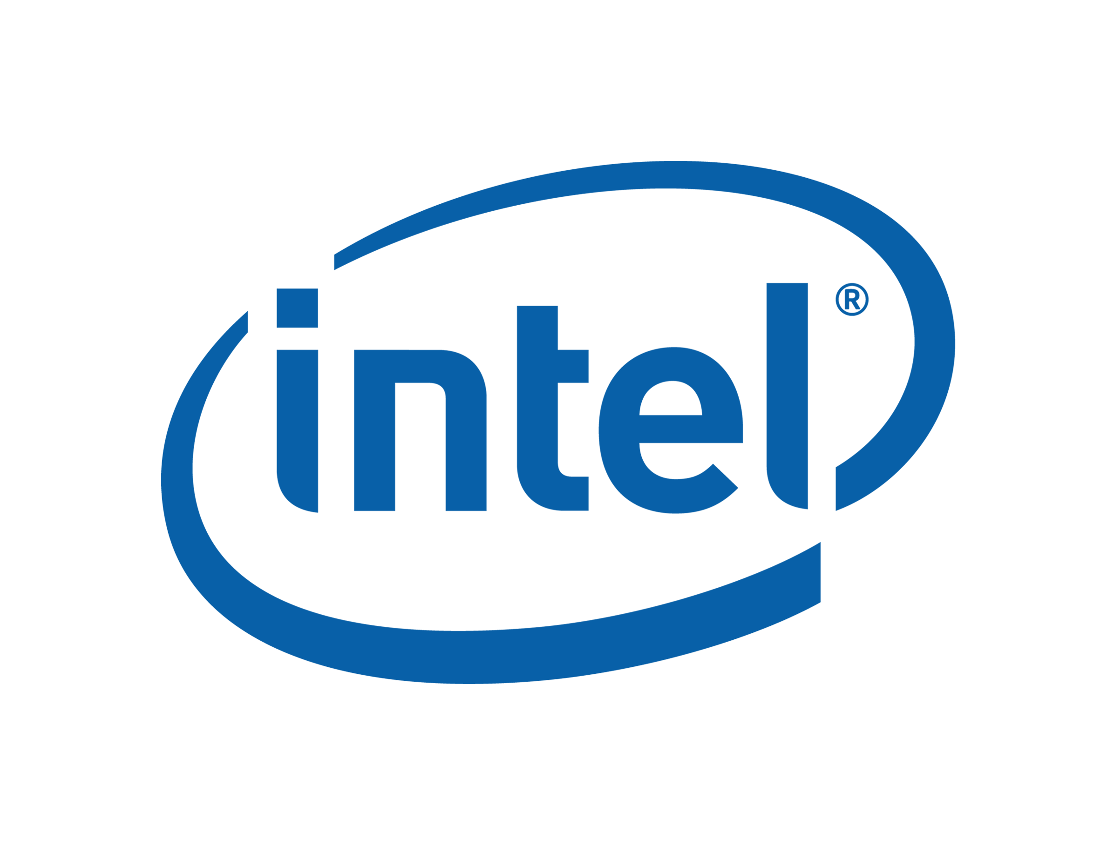

GenFds Utility Users Guide

July 2007

Revision 0.01

Intel Confidential

INFORMATION IN THIS DOCUMENT IS PROVIDED IN CONNECTION WITH INTEL® PRODUCTS. NO LICENSE, EXPRESS OR IMPLIED, BY ESTOPPEL OR OTHERWISE, TO ANY INTELLECTUAL PROPERTY RIGHTS IS GRANTED BY THIS DOCUMENT. EXCEPT AS PROVIDED IN INTEL’S TERMS AND CONDITIONS OF SALE FOR SUCH PRODUCTS, INTEL ASSUMES NO LIABILITY WHATSOEVER, AND INTEL DISCLAIMS ANY EXPRESS OR IMPLIED WARRANTY, RELATING TO SALE AND/OR USE OF INTEL PRODUCTS INCLUDING LIABILITY OR WARRANTIES RELATING TO FITNESS FOR A PARTICULAR PURPOSE, MERCHANTABILITY, OR INFRINGEMENT OF ANY PATENT, COPYRIGHT OR OTHER INTELLECTUAL PROPERTY RIGHT. Intel products are not intended for use in medical, life saving, or life sustaining applications.

Intel may make changes to specifications and product descriptions at any time, without notice.
Designers must not rely on the absence or characteristics of any features or instructions marked “reserved” or “undefined.” Intel reserves these for future definition and shall have no responsibility whatsoever for conflicts or incompatibilities arising from future changes to them.

Contact your local Intel sales office or your distributor to obtain the latest specifications and before placing your product order.
Intel and the Intel logo are trademarks or registered trademarks of Intel Corporation or its subsidiaries in the United States and other countries.
*Other names and brands may be claimed as the property of others.
Copyright © 2007, Intel Corporation. All rights reserved.
Contents
1 Introduction 1
1.1 Overview 1
1.2 Related Information 1
1.3 Terms 2
1.4 Conventions used in this document 4
1.4.1 Pseudo-code conventions 4
1.4.2 Typographic conventions 4
2 Command Line 7
2.1 Format for the GenFds command is: 7
2.1.1 Input Files 8
2.1.2 Output Files 8
2.1.3 Rules: 8

Revision History

Revision  Number | Description | Revision  Date
<0.01> | Initial release. | July 2007

§

Introduction

Overview
The FDF file describes information about flash parts as well as rules for combining binaries (Firmware Image) built from a DSC file. The output of the first phase of an EDK II build (as defined in the EDK II Build Specification) generates valid PE32/PE32+/Coff image files. GenFds performs the second phase of the build process during which consumes the images generated during the first phase, using statements and rules defined in the FDF file to place the PE32/PE32+/Coff images files into one or more EFI sections, then the EFI sections may get combined with other optional sections (version, depex, user interface) sections, into EFI Firmware File system (FFS) Sections. FFS images are put into Firmware Volumes (FVs,) and finally, the FV sections are combined into one or more Flash Device binary image (FD.)

Related Information
The following publications and sources of information may be useful, or are referred to by this specification:
EDKII FDF Specification, Version 0.31, Intel, 2007, http://TBD.
EDKII Base Tools Project Specification, Verison 0.23, Intel 2007, http://TBD.
Unified Extensible Firmware Interface Specification, Version 2.0, Unified EFI, Inc, 2006, http://www.uefi.org.
Unified Extensible Firmware Interface Specification, Version 2.1, Unified EFI, Inc, 2007, http://www.uefi.org.
Intel® Platform Innovation Framework for EFI Specifications, Intel, 2006, http://www.intel.com/technology/framework/.
Platform Initialization Specification Pre-EFI Initialization Core Interface, Version 1.0, Unified EFI, Inc, 2006, http://www.uefi.org/specs.
Platform Initialization Specification Driver Execution Environment Core Interface, Version 1.0, Unified EFI, Inc, 2006, http://www.uefi.org/specs
Platform Initialization Specification Shared Architectural Elements, Version 1.0, Unified EFI, Inc, 2006, http://www.uefi.org/specs.

Terms
The following terms are used throughout this document to describe varying aspects of input localization:
Component
An executable image. Components defined in this specification support one of the defined module types.
CIS
Core Interface Specification.
DXE
Framework Driver Execution Environment phase.
EFI
Generic term that refers to one of the versions of the EFI specification: EFI 1.02, EFI 1.10, or UEFI 2.0.
EFI 1.10 Specification
Intel Corporation published the Extensible Firmware Interface Specification. Intel has donated the EFI specification to the Unified EFI Forum, and the UEFI now owns future updates of the EFI specification. See UEFI Specification Version 2.x.
Foundation
The set of code and interfaces that glue implementations of EFI together.
Framework
Intel® Platform Innovation Framework for EFI consists of the Foundation, plus other modular components that characterize the portability surface for modular components designed to work on any implementation of the Tiano architecture.
GUID
Globally Unique Identifier. A 128-bit value used to name entities uniquely. An individual without the help of a centralized authority can generate a unique GUID. This allows the generation of names that will never conflict, even among multiple, unrelated parties.
Module
A module is either an executable image or a library instance. For a list of module types supported by this package, see module type.
Module Type
All libraries and components belong to one of the following module types: BASE, SEC, PEI_CORE, PEIM, DXE_CORE, DXE_DRIVER, DXE_RUNTIME_DRIVER, DXE_SMM_DRIVER, DXE_SAL_DRIVER, UEFI_DRIVER, or UEFI_APPLICATION. These definitions provide a framework that is consistent with a similar set of requirements. A module that is of module type BASE, depends only on headers and libraries provided in the MDE, while a module that is of module type DXE_DRIVER depends on common DXE components. For a definition of the various module types, see module type.
Protocol
An API named by a GUID as defined by the EFI specification.
PEI
Pre-EFI Initialization Phase.
PPI
A PEIM-to-PEIM Interface that is named by a GUID as defined by the PEI CIS.
Runtime Services
Interfaces that provide access to underlying platform-specific hardware that might be useful during OS runtime, such as time and date services. These services become active during the boot process but also persist after the OS loader terminates boot services.
SAL
System Abstraction Layer. A firmware interface specification used on Intel® Itanium® Processor based systems.
SEC
Security Phase is the code in the Framework that contains the processor reset vector and launches PEI. This phase is separate from PEI because some security schemes require ownership of the reset vector.
UEFI Application
An application that follows the UEFI specification. The only difference between a UEFI application and a UEFI driver is that an application is unloaded from memory when it exits regardless of return status, while a driver that returns a successful return status is not unloaded when its entry point exits.
UEFI Driver
A driver that follows the UEFI specification.

UEFI Specification Version 2.0
First version of the EFI specification released by The Unified EFI Forum. This specification builds on the EFI 1.10 specification and transfers ownership of the EFI specification from Intel to a non-profit, industry trade organization.

UEFI Specification Version 2.1

Current version of the EFI specification released by the Unified EFI Forum.
Unified EFI Forum
A non-profit collaborative trade organization formed to promote and manage the UEFI standard. For more information, see www.uefi.org.

Conventions used in this document
This document uses the typographic and illustrative conventions described below.

Pseudo-code conventions
Pseudo code describes algorithms in a more concise form. None of the algorithms in this document are intended to be compiled directly. The code is presented at a level corresponding to the surrounding text.
In describing variables, a list is an unordered collection of homogeneous objects. A queue is an ordered list of homogeneous objects. Unless otherwise noted, assume the ordering is First In First Out (FIFO).
Pseudo code is presented in a C-like format, using C conventions where appropriate. The coding style, particularly the indentation style, is used for readability and does not necessarily comply with an implementation of the Extensible Firmware Interface Specification.

Typographic conventions
This document uses the typographic and illustrative conventions described below:
Plain text | The normal text typeface is used for the vast majority of the descriptive text in a specification.
Plain text (blue) | Any plain text that is underlined and in blue indicates an active link to the cross-reference. Click on the word to follow the hyperlink.
Bold | In text, a Bold typeface identifies a processor register name. In other instances, a Bold typeface can be used as a running head within a paragraph.
Italic | In text, an Italic typeface can be used as emphasis to introduce a new term or to indicate a manual or specification name.
BOLD Monospace | Computer code, example code segments, and all prototype code segments use a BOLD Monospace typeface with a dark red color. These code listings normally appear in one or more separate paragraphs, though words or segments can also be embedded in a normal text paragraph.
Italic Monospace | In code or in text, words in Italic Monospace indicate placeholder names for variable information that must be supplied (i.e., arguments).
Plain Monospace | In code, words in a Plain Monospace typeface that is a dark red color but is not bold or italicized indicate pseudo code or example code. These code segments typically occur in one or more separate paragraphs.
See the glossary sections in the EFI 1.10 Specification and in the EFI Documentation help system for definitions of terms and abbreviations that are used in this document or that might be useful in understanding the descriptions presented in this document.
See the references sections in the EFI 1.10 Specification and in the in the EFI Documentation help system for a complete list of the additional documents and specifications that are required or suggested for interpreting the information presented in this document:
The EFI 1.10 Specification is available from the EFI web site http://developer.intel.com/technology/efi/. The EFI Documentation help system is available from the EFI web site http://developer.intel.com/technology/efi/help/efidocs.htm.

§

Command Line

Format for the GenFds command is:

GenFds [options]
Table 1 GenFds Command Options
Option | Description
-a, --arch <ARCHS> | ARCHS is a comma separated list containing one or more of: IA32, X64, IPF or EBC which should be built, overrides target.txt’s TARGET_ARCH
-p, --platform PlatformName.dsc | Build the platform specified by the DSC file name argument, over rides the ACTIVE_PLATFORM
-r, --rom_image FdUiName | Build the image using the [FD] section named by FdUiName.
-i, --FvImage UiFvName | Buld the FV image using the [FV] section named by UiFvName
-f, --filename Filename | Input FDF file and its format must follow FDF specification.
-o –outputDir | The output directory of Genfds tool. And this directory also should be the directory of the EFI file.
-w --workspace | The build workspace path.
--version | Print version and copyright of this program and exit
-v, --verbose | Turn on verbose output with informational messages printed. This is a count value, so specifying –vv can be used to increase the verbosity level.
-q, --quiet | disable all messages except FATAL ERRORS
-d, --debug [#] | Enable debug messages, at level #
-h, --help | Print copyright, version and usage of this program and exit code: PASS

Input Files
target.txt,platform.dsc, flashmap.fdf, package.dec and module.inf

Output Files
Varies depending on options and targets: Ffs, Fv, FD, Section.

Usage Rules:
- The FDF file must be pointed out. And the FDF file must follow the format of FDF’s specification otherwise tool will throw a exception and stop the build.
- The outputDir must be pointed out. Tool will generate a FV directory which includes a FFS directory, Fv file, Fv INf file and Fd file. The FFS directory contents all modules directory which contents Ffs files and section files. All output of GenFds tool output will be in FV directory. The FV directory structure is following. The outputDir should be point part of Efi file path. That mean for each of module which descript in the FDF file as the ‘InfFIle’ statement format the GenFds tool would find out it’s input files from the path of “ $(outputDir)\ $(Arch) \ $(ActivePlatfromName) \$(ModuleName) \$(ModuleName) \DEBUG”
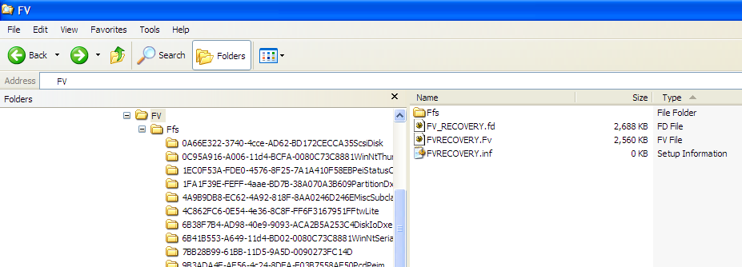

- If Arch list was pointed out, GenFds tool will use this Arch instead of Arch List in Target.txt file
- If Workspace was not pointed out, GenFds tool will use the Workspace path which set in OS environment.
- If ActivePlatform was pointed out, GenFds tool will use this active platform as the current platform instead of active platform which in Target.txt file.
- GenFds tool support 2 kinds of path in command line. Absolutely path and relative workspace path. The GenFds tool also support $(WORKSPACE) marco in path. For example, if the input Fdf like that $(WORKSPACE)\NT32PKg\Nt32.fdf, the tool will expand the $(WORKSPACE) macro with real path.
Example
1. WORKSAPCE has already set. $(WORKSPACE) = c:\work\EdkII. The Fdf file is in c:\work\EdkII\Nt32pkg\Nt32pkg.fdf. Output directory is c:\work\EdkII\Build\Nt32\Debug_MyTools. ActivePlatform is C:\work\EdkII\Nt32Pkg\Nt32Pkg.dsc
GenFds –f c:\work\EdkII\Nt32pkg\Nt32pkg.fdf –o c:\work\EdkII\Build\Nt32\Debug_MyTools –p c:\work\EdkII\Nt32pkg\Nt32Pkg.dsc
GenFds –f $(WORKSPACE)\Nt32Pkg\Nt32Pkg.fdf –o $(WORSPACE)\Build\Nt32\Debug_MyTools –p $(WORKSAPCE)\Nt32Pkg\Nt32Pkg.dsc

GenFds –f Nt32Pkg\Nt32Pkg.fdf –o Build\Nt32\Debug_MyTools –p Nt32Pkg\Nt32Pkg.dsc
2. Generate one FD which defined in FDF file. Use ‘-r’ and Fd UIName. The Fd UIName is the name which defined in the FDf file, for detail information refer to FDF specification
GenFds –f GenFds –f c:\work\EdkII\Nt32pkg\Nt32pkg.fdf –o c:\work\EdkII\Build\Nt32\Debug_MyTools –p c:\work\EdkII\Nt32pkg\Nt32Pkg.dsc –r Fv_Recovery
3. Generate one FV which defined in FDF file. Use ‘-i’ and FV UiName. The FV UIName is the name which defined in the FDF file, for detail information refers to FDF specification.
GenFds –f c:\work\EdkII\Nt32pkg\Nt32pkg.fdf –o c:\work\EdkII\Build\Nt32\Debug_MyTools –p c:\work\EdkII\Nt32pkg\Nt32Pkg.dsc –I FVRecovery

4. Use command line option to replace the Arch List in Target.txt.
GenFds –f c:\work\EdkII\Nt32pkg\Nt32pkg.fdf –o c:\work\EdkII\Build\Nt32\Debug_MyTools –p c:\work\EdkII\Nt32pkg\Nt32Pkg.dsc
-a IA32, X64

